Aerosonde UAV Longitudinal Stability and Pitch Autopilot Design

MATLAB/Simulink Based Flight Control System Development

Project Information
Project Title: Aerosonde UAV Longitudinal Stability & Pitch Autopilot
Software Used: MATLAB, Simulink, Control System Toolbox
Control Method: PID-Based Closed-Loop Pitch Control
Aircraft Model: Aerosonde UAV
Project Type: Flight Dynamics and Control Engineering Project

Abstract
This project presents the modeling, analysis, and closed-loop control design of the longitudinal dynamics of an Aerosonde Unmanned Aerial Vehicle (UAV) using MATLAB and Simulink. A state-space representation of the aircraft longitudinal dynamics was developed using published aerodynamic stability derivatives.
The project focused on:
- Developing a longitudinal state-space aircraft model
- Evaluating open-loop dynamic stability
- Designing a PID-based pitch autopilot
- Performing closed-loop transient analysis
- Implementing disturbance rejection capability
- Evaluating frequency-domain stability margins
- Creating a professional Simulink control architecture
The system was simulated under multiple operating conditions including step pitch commands and external disturbance injection. Stability and performance were evaluated using step response analysis, root locus plots, and Bode stability margins.

1. Introduction
Modern UAV flight control systems rely heavily on closed-loop feedback control for maintaining stability and tracking desired commands. Longitudinal stability is particularly important because it governs aircraft pitch behavior, flight-path stability, and overall controllability.
In this project, an Aerosonde UAV longitudinal model was developed and controlled using a PID-based autopilot implemented in MATLAB and Simulink.
The project was structured to replicate a professional aerospace controls workflow:
- Aircraft modeling
- State-space formulation
- Open-loop analysis
- Controller design
- Simulink implementation
- Stability analysis
- Disturbance rejection testing
- Frequency-domain validation

2. Project Objectives
The primary objectives of this project were:
- Develop a longitudinal state-space model for an Aerosonde UAV
- Analyze open-loop longitudinal stability characteristics
- Design a PID pitch-hold controller in Simulink
- Evaluate closed-loop transient response characteristics
- Implement actuator saturation and disturbance injection
- Perform root locus and frequency-domain analysis
- Validate controller robustness under disturbances
- Create a professional aerospace controls simulation workflow

3. Aircraft Parameters and Aerodynamic Data
The aircraft parameters and aerodynamic coefficients used in this project were obtained from publicly available Aerosonde UAV data.

3.1 Aircraft Parameters
Parameter | Symbol | Value
Mass | m | 13.5 kg
Wing Area | S | 0.55 m²
Mean Aerodynamic Chord | c | 0.19 m
Air Density | ρ | 1.225 kg/m³
Gravity | g | 9.81 m/s²

3.2 Aerodynamic Coefficients
Coefficient | Value
CLa | 3.5
CDa | 0.03
Cma | -0.38
CLq | 2.8
Cmq | -3.6
CLδe | 0.36
Cmδe | -0.5
These coefficients were used to formulate the longitudinal state-space dynamics.

4. Longitudinal State-Space Model
The aircraft longitudinal dynamics were represented in state-space form:
[ x = Ax + Bu]
[ y = Cx + Du ]
Where:
- x = state vector
- u = elevator deflection input
- y = pitch angle output
The state vector consisted of:
[ x = [u, w, q,θ ] ^T]
Where:
- u = forward velocity perturbation
- w = vertical velocity perturbation
- q = pitch rate
- θ = pitch angle

4.1 System Matrices
The implemented state-space matrices were:

A Matrix
A = [ -0.02 0.10 0 -9.81
-0.30 -2.50 20.00 0
0.001 -0.05 -1.20 0
0 0 1 0
]

B Matrix
B = [ 0
-0.8
-1.5
0
]

C Matrix
C = [ 0 0 0 1]

D Matrix
D = [0]

5. Open-Loop Stability Analysis
The initial aircraft model was analyzed in open-loop condition to determine inherent longitudinal stability.

5.1 Open-Loop Eigenvalues
The eigenvalues obtained from MATLAB were:
[ -1.8640 0.7857i ]
[ 0.0040 0.2048i ]
The presence of eigenvalues with positive real components indicated that the aircraft model exhibited unstable longitudinal dynamics in open-loop configuration.
This justified the need for a feedback control system.

5.2 Root Locus Analysis
A root locus analysis was performed to study the movement of closed-loop poles as controller gain varied.

Root Locus Plot
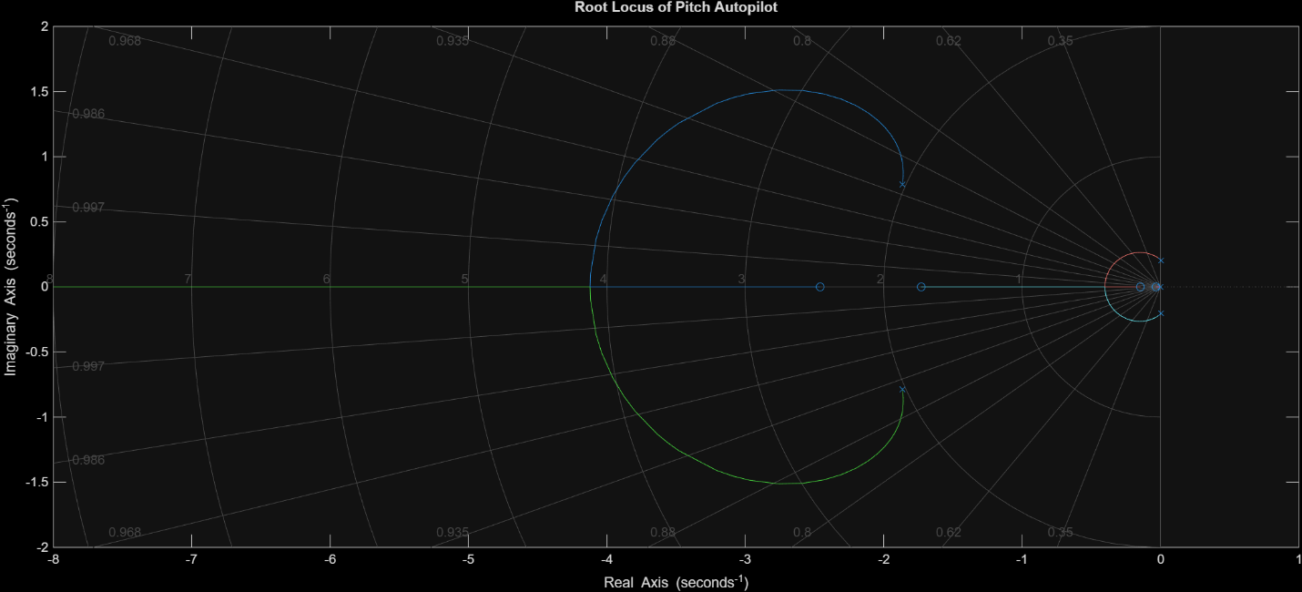
Root Locus
The root locus demonstrated:
- Closed-loop stabilization capability
- Dominant pole movement toward stable regions
- Feasible PID tuning range

6. PID Pitch Autopilot Design
A PID controller was implemented to regulate aircraft pitch angle.
The controller structure used was:
[ G_c(s) = K_p + + K_d s ]

6.1 Controller Tuning Strategy
The PID gains were tuned manually through iterative simulation.

Initial Problems Encountered
During early simulations, several issues were observed:
- Diverging pitch response
- Unstable oscillatory behavior
- Excessive control authority
- Unrealistic actuator commands
- Improper feedback sign convention
The instability was traced to:
- Incorrect feedback direction
- Aggressive controller gains
- Absence of actuator saturation
- Open-loop unstable aircraft dynamics

6.2 Engineering Corrections Applied
The following corrections were implemented:

1. Reverse Control Action
A negative gain block (-1) was introduced between the PID controller and aircraft model to correctly represent elevator control action.
This corrected the sign convention between elevator deflection and pitch response.

2. Actuator Saturation
A saturation block was added to limit elevator command magnitude.
This prevented:
- Unrealistically large control inputs
- Numerical instability
- Excessive oscillations
The saturation block improved physical realism and controller robustness.

3. Disturbance Injection
A disturbance injection block was added to simulate wind gust disturbances.
This allowed evaluation of:
- Controller robustness
- Disturbance rejection capability
- Closed-loop stability under external perturbations

6.3 Final PID Gains
The final tuned PID gains were:
Gain | Value
Kp | 0.8
Ki | 0.05
Kd | 0.3
These values provided:
- Stable closed-loop behavior
- Minimal overshoot
- Smooth pitch tracking
- Improved robustness

7. Simulink Closed-Loop Architecture
A complete closed-loop pitch autopilot architecture was developed in Simulink.
The model included:
- Pitch command input
- Error computation
- PID pitch controller
- Reverse control action
- Actuator saturation
- Wind gust disturbance injection
- Aircraft longitudinal dynamics
- Feedback loop
- Pitch response visualization

7.1 Final Simulink Architecture
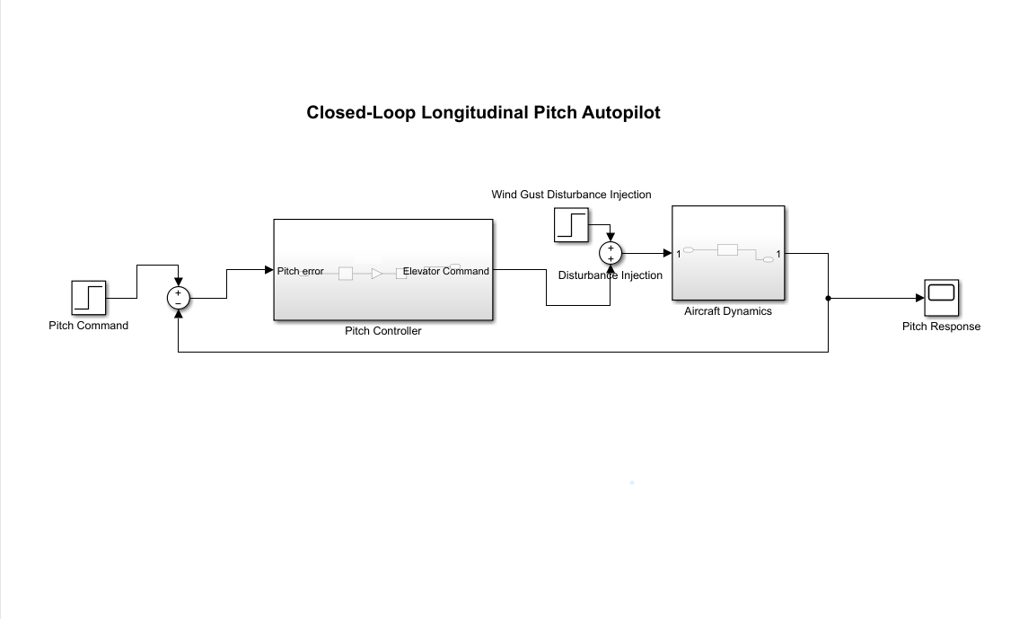
Simulink Architecture
The final architecture represents a professional aerospace feedback control implementation.

Closed-Loop Response Analysis
losed-loop simulations were performed to evaluate transient response characteristics.
The aircraft successfully tracked commanded pitch inputs while maintaining stability.

8.1 Closed-Loop Pitch Response
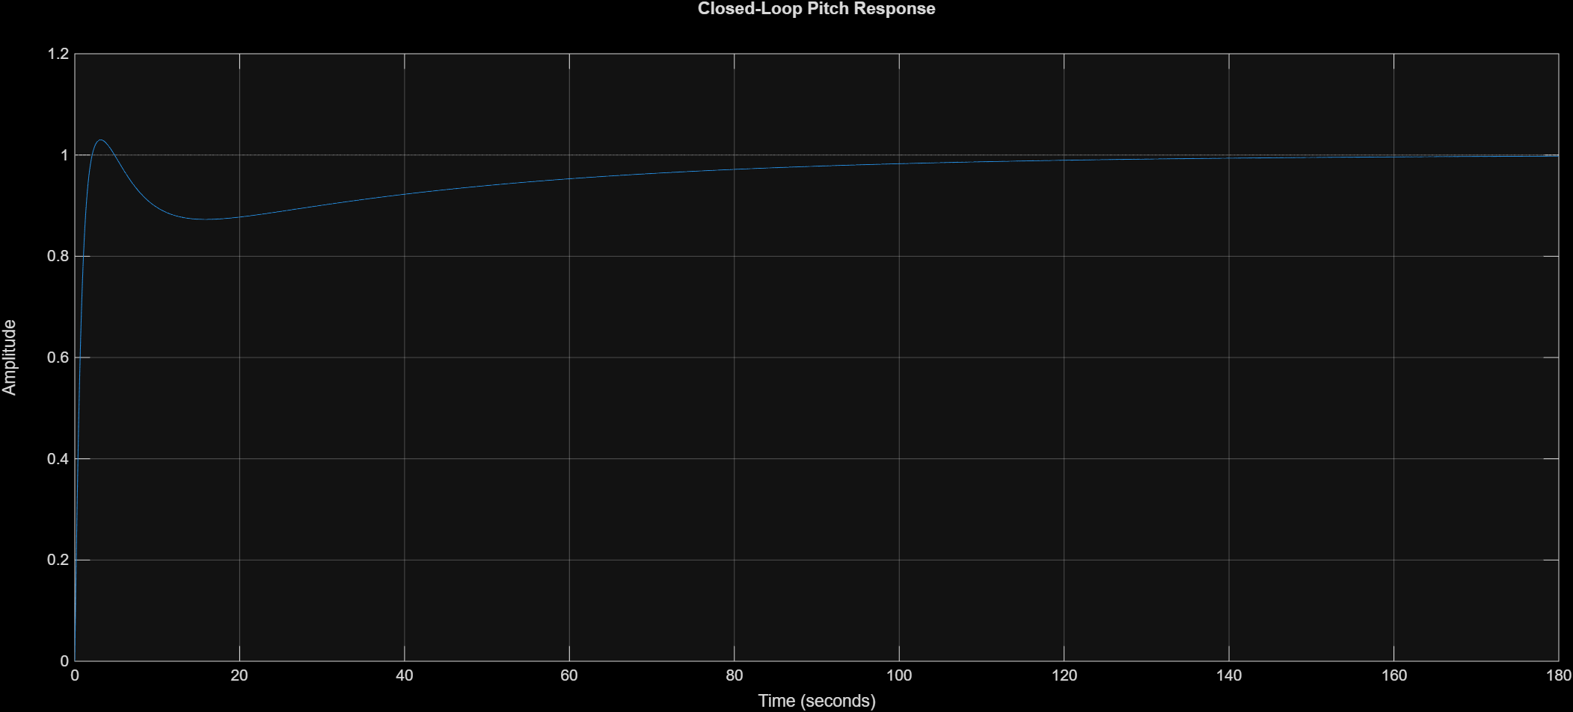
Closed Loop Response
The response demonstrated:
- Stable pitch tracking
- Low overshoot
- Smooth transient behavior
- Acceptable settling time

8.2 Time-Domain Performance Metrics
MATLAB step response analysis produced the following performance metrics:
Metric | Value
Rise Time | 1.3004 s
Settling Time | 94.0104 s
Peak Time | 3.1333 s
Overshoot | 2.9969 %
Steady-State Pitch Angle | 0.9968 rad
The controller achieved stable tracking with low overshoot and acceptable transient performance.

9. Disturbance Rejection Analysis
To evaluate controller robustness, a disturbance input representing a wind gust was introduced into the system.
The controller successfully compensated for the disturbance while maintaining stable aircraft response.

9.1 Disturbance Rejection Response
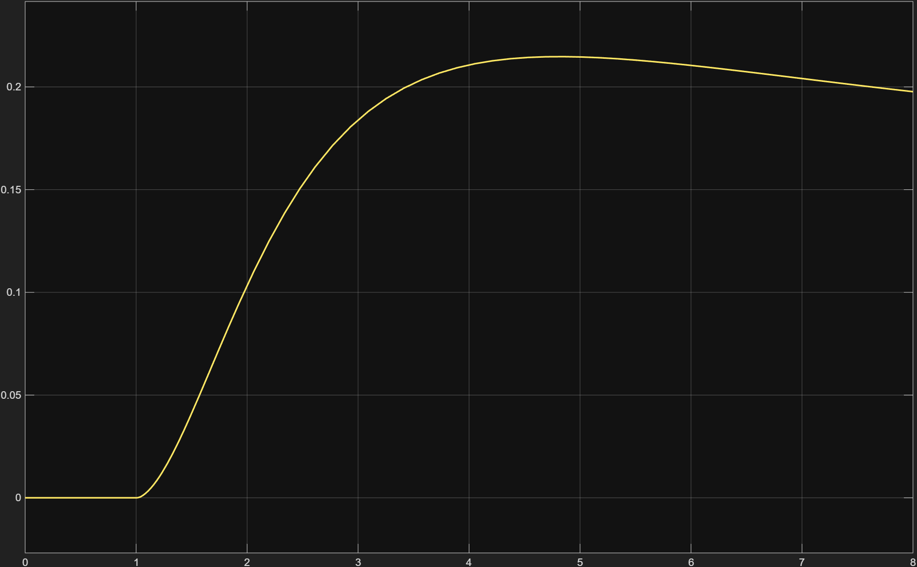
Disturbance Rejection
Observations:
- The aircraft remained stable after disturbance injection
- The PID controller suppressed disturbance effects
- The system recovered without divergence
- The response remained bounded and physically realistic
This demonstrated satisfactory disturbance rejection capability.

10. Frequency-Domain Stability Analysis
Frequency-domain analysis was performed using Bode plots and stability margin calculations.

10.1 Bode Plot
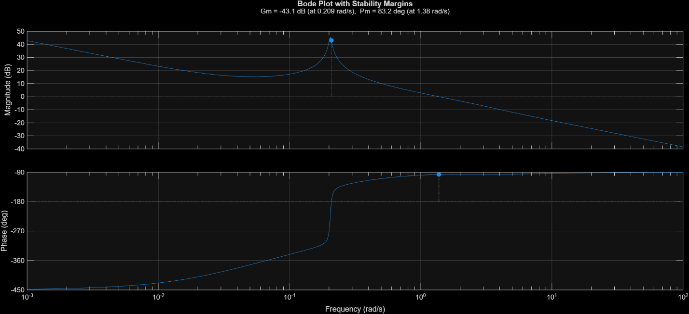
Bode Plot

10.2 Stability Margins
The following stability margins were obtained:
Parameter | Value
Gain Margin | 0.0070
Phase Margin | 83.2263°
Gain Crossover Frequency | 0.2085 rad/s
Phase Crossover Frequency | 1.3786 rad/s

10.3 Interpretation
The high phase margin indicated:
- Good relative stability
- Robust closed-loop performance
- Strong damping characteristics
- Reduced oscillatory tendency
The frequency-domain analysis confirmed the effectiveness of the controller design.

11. Key Engineering Challenges Faced
Several engineering challenges were encountered during the project.

11.1 Open-Loop Instability
The aircraft model exhibited unstable poles in open-loop condition.

Solution
A PID-based feedback controller was designed and tuned to stabilize the longitudinal dynamics.

11.2 Incorrect Feedback Direction
Initial simulations produced diverging responses due to incorrect sign convention.

Solution
A reverse control action block (-1 gain) was inserted between controller and aircraft dynamics.

11.3 Unrealistic Actuator Commands
Without actuator limits, the controller generated excessively large elevator commands.

Solution
A saturation block was introduced to constrain elevator deflection.

11.4 Controller Oscillations
Aggressive gains initially caused oscillatory and unstable responses.

Solution
PID gains were manually tuned iteratively using repeated simulation and transient response evaluation.

12. Final Project Outcomes
The final system successfully achieved:
- Closed-loop longitudinal stabilization
- Pitch command tracking
- Low overshoot response
- Stable transient performance
- Disturbance rejection capability
- Frequency-domain stability validation
- Professional Simulink implementation
The project demonstrated a complete aerospace control-system development workflow.

13. Skills Demonstrated
This project demonstrated practical engineering experience in:
- Flight dynamics
- Aircraft longitudinal stability
- State-space modeling
- MATLAB programming
- Simulink system design
- PID controller design
- Control system tuning
- Root locus analysis
- Bode stability analysis
- Aerospace feedback control systems

14. Conclusion
This project successfully developed and analyzed a longitudinal pitch autopilot for an Aerosonde UAV using MATLAB and Simulink.
The aircraft longitudinal dynamics were modeled using state-space methods, and a PID controller was designed to stabilize the inherently unstable open-loop system.
Closed-loop simulations demonstrated stable pitch tracking, low overshoot, acceptable transient performance, and effective disturbance rejection.
The final implementation represents a realistic aerospace control-system workflow involving modeling, controller design, robustness analysis, and simulation-based validation.
This project significantly strengthened understanding of flight dynamics, control-system design, and professional aerospace simulation practices.

Appendix

MATLAB Files
- aircraft_parameters.m
- longitudinal_model.m
- closed_loop_analysis.m
- frequency_analysis.m

Simulink Model
- closed_loop_pitch_autopilot.slx

Generated Plots
- closed_loop_response.png
- disturbance_rejection.png
- root_locus.png
- bode_plot.png
- final_simulink_architecture.png

